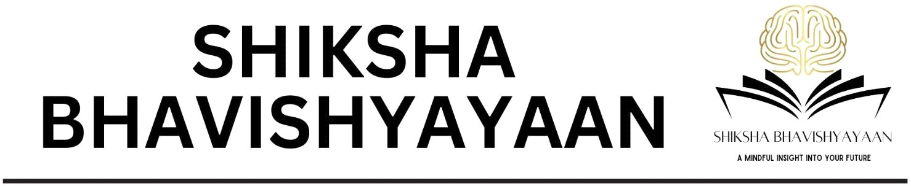

Date: 04/12/2025
TO WHOMSOEVER IT MAY CONCERN
This is to certify that St. Xavier’s College,Maharo, Dumka, Jharkhand has successfully completed the Mental Health and Wellness Assessments for their students. The assessments conducted include the Career Test, Stress & Mood Profiler, Skill Assessment Test, and Anger Index Scale. In addition, the college completed the Intelligence Test (IQ) for cognitive ability assessment, Emotional Intelligence Test for evaluating social-emotional competencies, Self-Efficacy Test to measure confidence and capability, and the Personality Profiler for behavioural pattern analysis. The Parent–Child Relationship Test was administered to understand the family support system, along with the Personal Problems Scale to identify individual challenges and the Screen Addiction Test to evaluate digital dependency. Further assessments included the Social Values Test for ethical orientation, the Creativity Test for innovation potential, the Drive & Dedication Assessment to analyse motivation and commitment, the Aptitude Test for multi-dimensional capability assessment, and the Social Intelligence Scale to evaluate interpersonal competency. These all tests are approved by AICTE.
These assessments were conducted to support the holistic development and well-being of the students.
Saadgi Malhotra
Founder Director
Shiksha Bhavishyayaan
Email: info@bhavishyayaan.com, shikshabhavishyayaan@gmail.com
Phone: +91-7043200432
Website: www.bhavishyayaan.com
AICTE Certified | NEP 2020 Aligned | "A Mindful Insight into Your Future"

