Report on Orientation Programme 2025-2026 at St. Xavier’s College, Maharo, Dumka
St. Xavier’s College, Maharo, Dumka, affiliated to Sido Kanhu Murmu University, conducted a two-day Orientation Programme for the academic session 2025–2026 to welcome and familiarize the newly admitted students with the college environment, ethos, and academic structure. The programme was held in the AV Room, commencing on Day 1 at 9:00 AM with the Lighting of the Lamp by Fr. Jesu Raj, SJ, Fr. Joby Kachappally, SJ (Treasurer, SXCD), Dr. Roy, Dr. Usha Kiran Tudu, and a fresher representative. This was followed by a Hymn and Prayer led by hostel girls and Fr. Jesu Raj, SJ.
The Welcome Address was delivered by the Principal, after which the College Management presented a brief session on The Society of Jesus. Asst. Prof. Amit Kumar Hansdak gave an insightful talk on Jesuit Institutions in India and the Raiganj Province, followed by an informative session on the college’s history and vision by the Principal. A short break was given from 10:20 to 10:55 AM.
Post-break, Dr. Deepak Kothriwal, HOD of Political Science, explained the college rules and regulations, and the session concluded with the Principal’s presentation on the National Education Policy (NEP) 2020.
On Day 2, the programme began at 9:00 AM with Group Formation and Activities coordinated by Asst. Professors Binay, Lobbo, Alisha, and Alok. This was followed by a motivational talk by Fr. Dr. Damian Tudu SJ, Principal of St. Xavier’s Inter College, Dumka, and Fr. Jesu Raj, SJ. An interactive session and doubt clarification was facilitated by the Principal at 10:45 AM. The programme concluded with Departmental Orientation at 11:00 AM conducted by respective Heads of Departments.
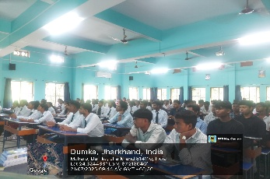
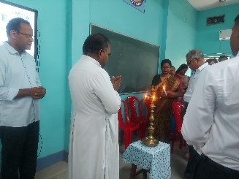
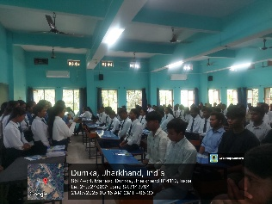
The orientation programme successfully acquainted the students with the institution’s values, academic policies, and departmental framework, thereby laying a strong foundation for their academic journey ahead.
