BizWhiz: Gateway to the Corporate World
The Department of Commerce, St. Xavier’s College, Maharo, Dumka, organized an engaging business quiz competition titled “BizWhiz: Gateway to the Corporate World” on Friday, 1st August 2025, with the aim of introducing UG Semester I students to the dynamic world of business and corporate affairs. This interactive event served as a welcome activity for the newly admitted students, whose classes commenced on 23rd July 2025.
The quiz was exclusively designed for Semester I students and witnessed enthusiastic participation. The students were divided into teams comprising six members each. The competition was conducted smoothly with clearly defined rules and regulations, ensuring a fair and intellectually stimulating experience for all. The Quiz Master for the day was Jeet Das, a student of Semester IV, assisted by Fr. Jesuraj, who contributed significantly to organizing and conducting the event.
Rev. Fr. Dr. Varghese Palli, S.J., Principal of the college, graced the occasion as the Chief Guest. The event was also attended by Dr. S.P. Mallick and Mr. Binay Herold Dumdum, Assistant Professors in the Department of Commerce. Students from Semesters III, IV, and V formed the audience and encouraged the participants.
Group 1 emerged as the winners with 55 points, consisting of Anis Anand Soren, Akash Hansda, Francis Hembrom, Hari Soren, Prince Emmanuel Marandi, and Bikash Tudu. Group 3 was the runner-up with 50 points, comprising Paulus Hembrom, Nirmal Murmu, Nancy Marandi, Nely Murmu, Sumita Soren, and Priyanka Kumari Besra. The competition concluded with a thrilling tie-breaker round, where Group 1 correctly answered the deciding question.
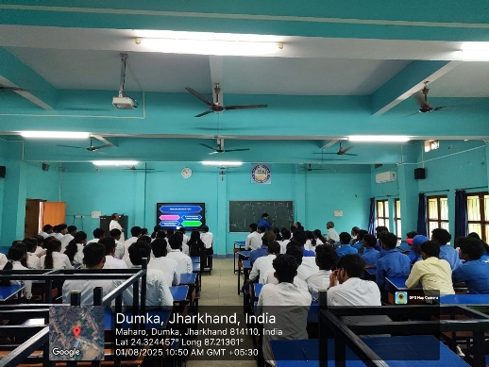
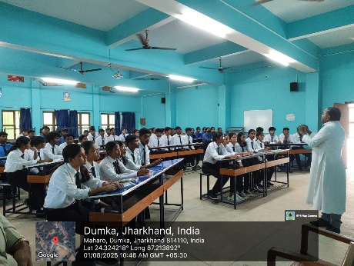
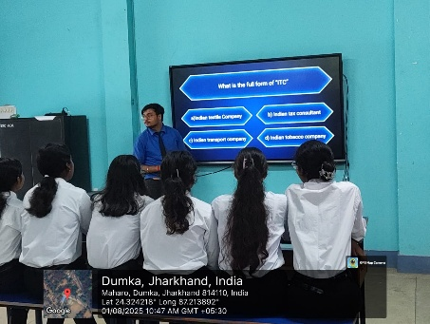
The quiz proved to be a great success in fostering team spirit, critical thinking, and business awareness among the first-year students.
