Celebrating the 76th Republic Day at St. Xavier's College, Maharo, Dumka

Today, our college came alive with patriotism as the celebrated the 76th Republic Day with great zeal and enthusiasm. The event was graced by the presence of Dr. R.K. Roy, our esteemed Guest of Honour, whose inspiring words motivated everyone to contribute towards nation-building.
Students from both the college and intermediate sections participated with full fervor. The event commenced with soulful patriotic songs presented by the talented students of the Geography Department led by Sangeeta Marandi, creating an atmosphere filled with pride and unity.
Sunita Marandi and Samuel Hembrom captivated the audience with their thought-provoking speeches, reflecting on the significance of the Constitution and the responsibilities of citizens in upholding its values.
The program concluded with a heartfelt vote of thanks by Mr. Amit Kumar Hansdak, Head of the Department of Geography, who expressed gratitude to all the participants, organizers, and attendees for making the event a grand success.
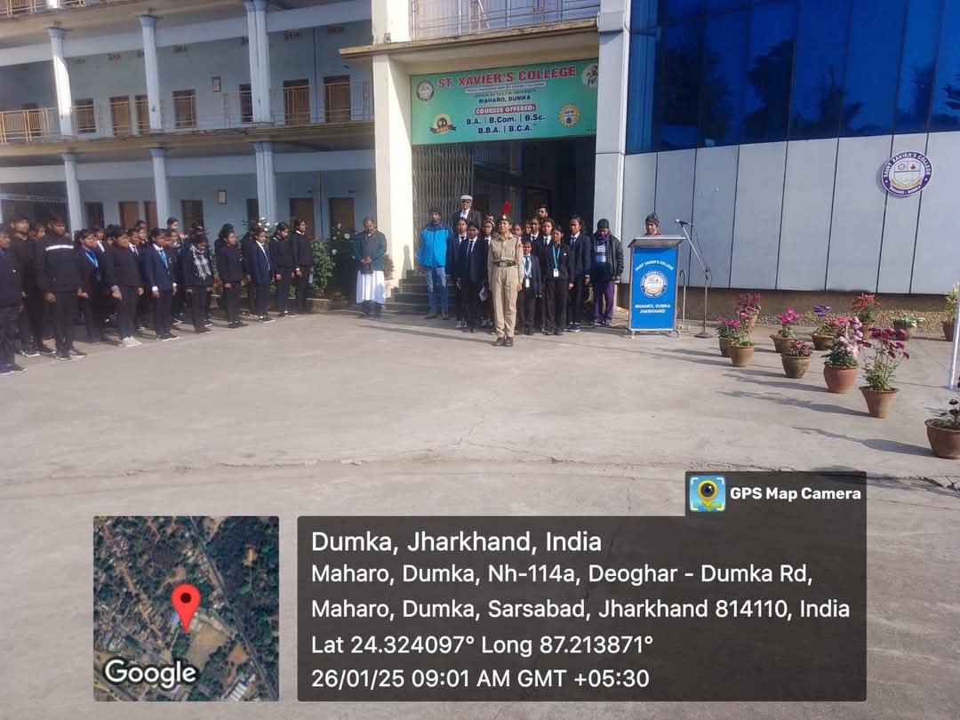
On this auspicious day, we reaffirmed our commitment to the ideals of justice, liberty, equality, and fraternity that our Constitution enshrines.
