UNIVERSITY TOPPERS 2020-2023
Aman Kumar , Stuti das and Sneha Kumari of St. Xavier's College, Maharo , Dumka are the SKM University Toppers for the academic year 2020-2023. Aman Kumar, from the Department of Mathematics, secured the first rank in the University and also was the best Graduate of the University for the academic year 2020- 2023. Stuti Das from the Department of Commerce and Sneha Kumari from the Department of BBA . Their dedication, hard work, and commitment to academics have earned them accolades from peers and faculty alike. All students expressed gratitude towards their Professors for continuous guidance and motivation throughout their academic journey.
The Governer of Jharkhand His Excellency Santosh Gangwar and the Vice-Chancellor of SKM University, .Prof. (Dr.) Bimal Prasad Singh, congratulated the achievers and emphasized the university's commitment on 24th September at Convention Center Dumka to nurturing talent and providing quality education. "These students have set a great example for others to follow. Their achievements reflect the university’s mission of academic excellence and holistic development," he stated.
A felicitation ceremony was held to honor the achievers on 25th September 2024 in the Inigo Auditorium, Secrectary of the college Rev. Fr. Vargese Puttusheri S.J, Principal Rev.Fr. Dr. Varghese Palli S.J , Vice Pricipal Rev. Fr. Jesuraj S.J , HODs and all the faculty members also congratulated the students.
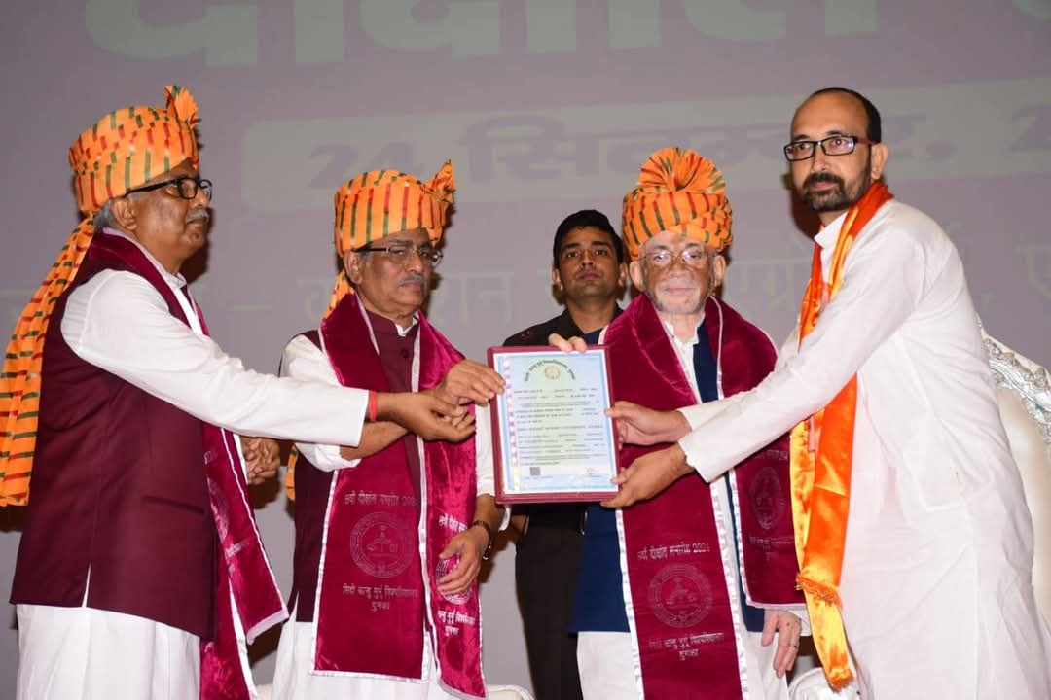
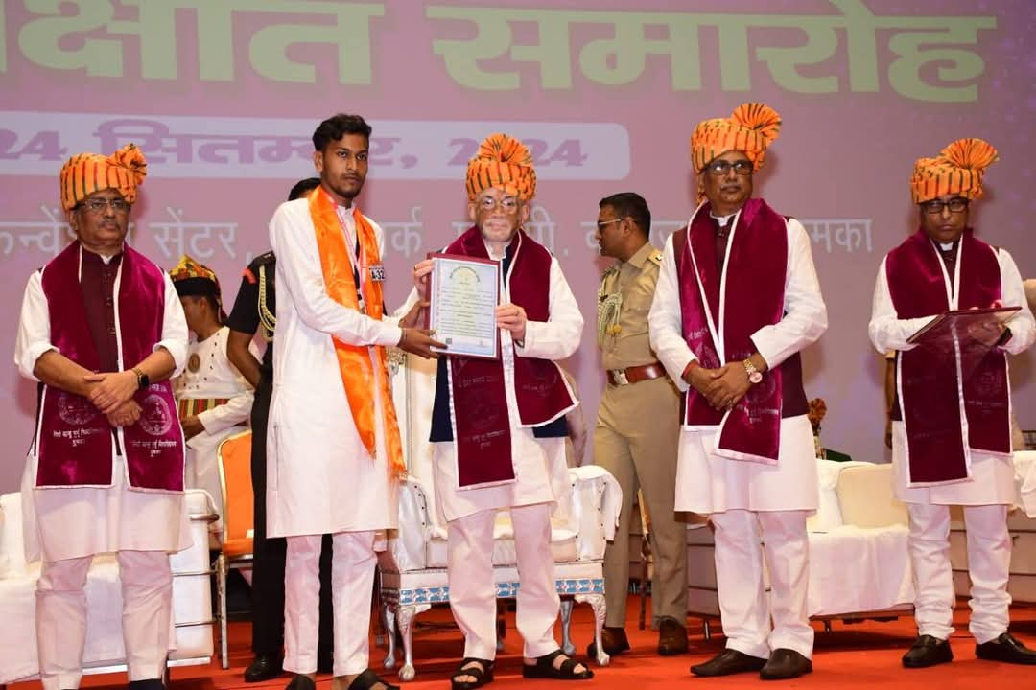
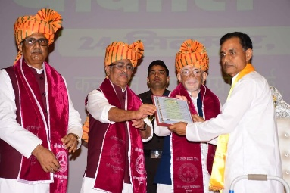
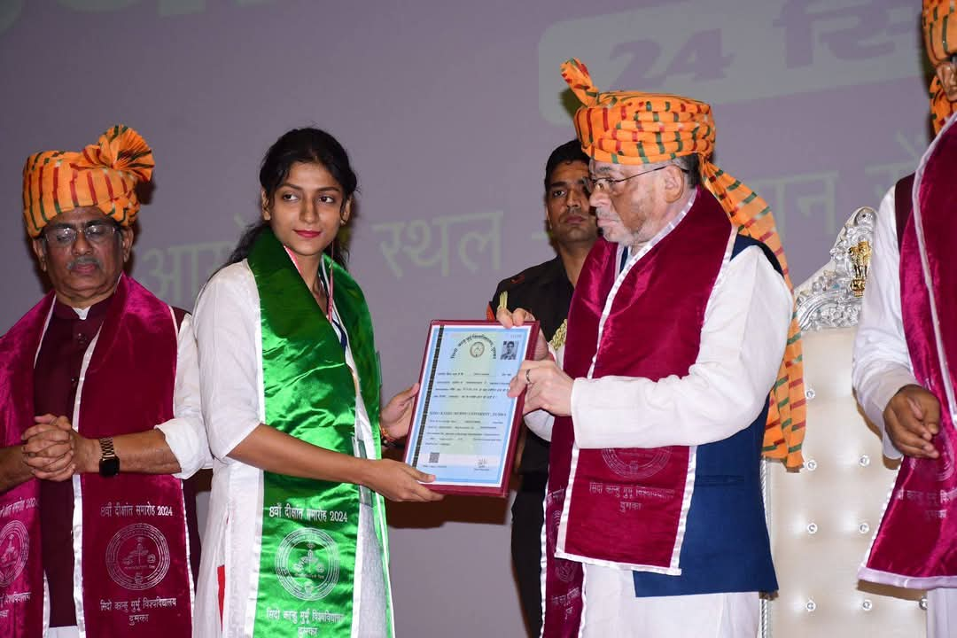
The Xaverian family also congratulated Dr. Gopinath Gorai ( Chemistry), Dr. Mahesh Deo (Hindi), Dr. Pankaj Mishra (Hindi) and Dr. Kusum Kanan Mishra (BBA) for their successful completion of their Doctrate Degree.

