SKMU WRESTLING TOURNAMENT 2024-2025
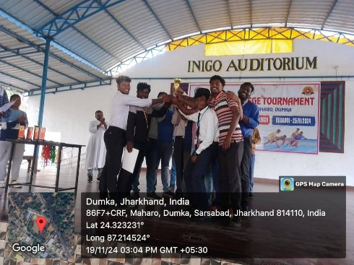
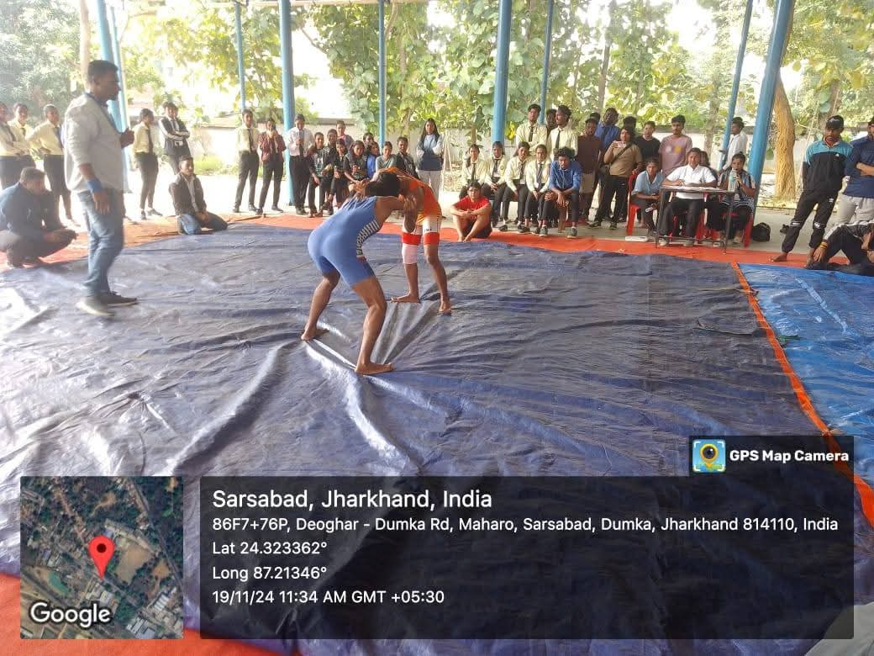
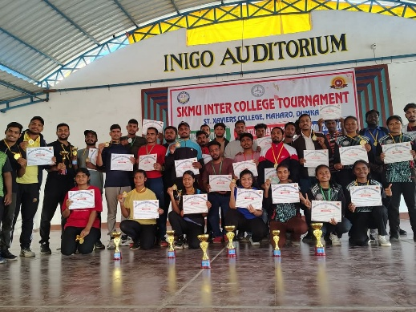
St. Xavier's College, Maharo, Dumka emerges victorious in Men's Free style Wrestling amd Women Wrestling in SKMU Inter College Wrestling tournament held on 19th November, 2024. The participating colleges were Sahibganj College, Sahibganj, AS College Deoghar, Deoghar College, Deoghar, SBSSPSJ College Pathargama and St. Xavier's College, Maharo, Dumka. The tournament started with the words of encouragement from the Principal of the College Rev. Fr. Dr. Varghese Palli S.J. There were about 55 participants who took part in different weight categories in the tournament. The touramnet concluded with the prize distribution and vote of thanks by the Vice Principal of the College Rev. Fr. Jesuraj S.J . He thanked all the Sports Coordinators of participating colleges, the students and the faculty members. Also special mention was given to Mr. Farid Khan the Sports Coordinator of the College for organising the tournament.
