𝐓𝐑𝐄𝐄 𝐏𝐋𝐀𝐍𝐓𝐀𝐓𝐈𝐎𝐍 𝐏𝐑𝐎𝐆𝐑𝐀𝐌𝐌𝐄

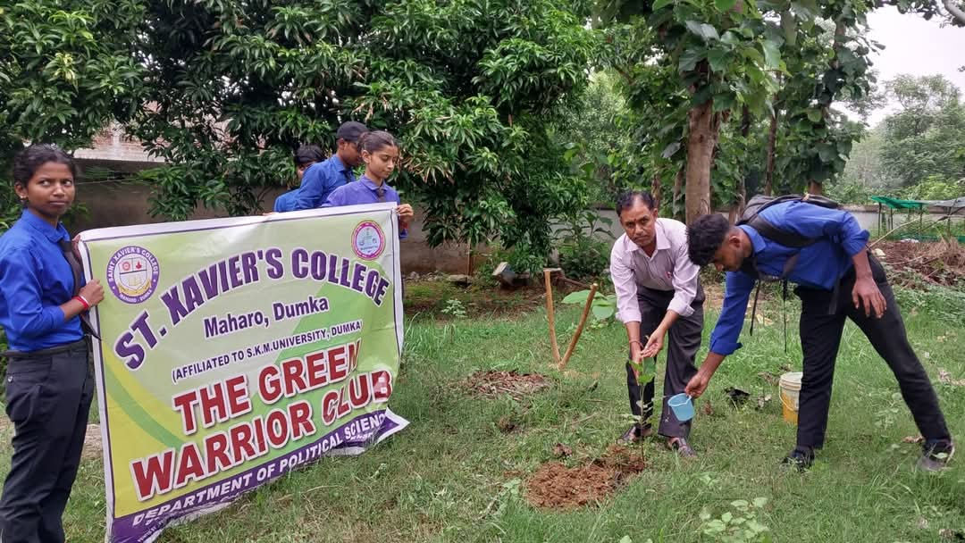
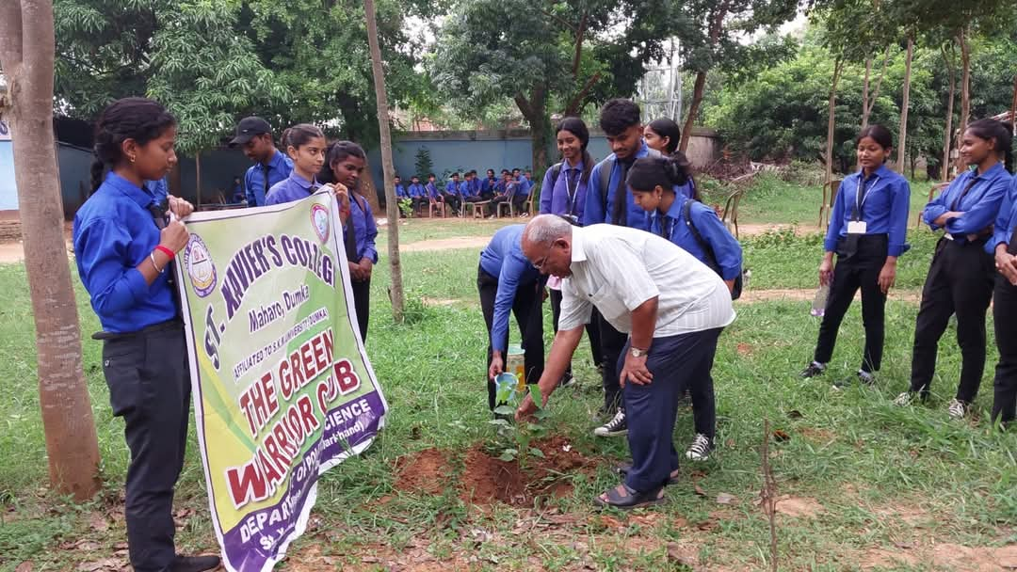
On the occasion of World Population Day, a tree plantation program was organized by "The Green Barriers Club" of the college under the leadership of the Department of Political Science of St. Xavier's College Maharo. Students and Faculty Members from various departments took part on it. Principal of the college Rev. Fr. Dr. Varghese Palli S.J. addressed the students that the number of trees is not increasing in the same proportion as the world's population. Trees are being cut alarminy, so it is important that in order to reduce global warming, every person should pledge to plant at least 10 trees in his life. On this occasion, the Head of the Department of Political Science Dr. Deepak Kumar Kothariwal, Head of the Hindi Department Dr. Mahesh Kumar Dev, Head of the English Department Mr. Himadri Shekhar Dutta and the college Sports Officer Mr. Farid Khan also planted trees and shared the message to plant as many trees as possible. Students of the Department of Political Science Saloni, Sandeep, Rimi Pooja, Joba, Sunita, Shanti, Vishwanath and Prem also participated enthusiastically in the program and took a firm resolve to protect the environment.
