Celebration of the Feast of St. Ignatius of Loyola at St. Xavier’s College, Maharo, Dumka
Date: 31st July, 2025
The Feast of St. Ignatius of Loyola, the revered founder of the Society of Jesus (Jesuits), was solemnly celebrated at St. Xavier’s College, Maharo, Dumka on 31st July, 2025. The occasion was marked with spiritual fervor, community participation, and a sense of unity across all Jesuit educational units.
The day commenced with the Holy Eucharist Celebration held at 8:00 a.m. in the College Inigo Auditorium. The solemn mass was presided over by Rev. Fr. Sonatan Kisku, the Auxiliary Bishop of the Diocese of Dumka. In his homily, Bishop Kisku reflected on the profound legacy of St. Ignatius of Loyola and emphasized the relevance of SpiritualExercise and Ignatian values—faith, service, and commitment to justice—in today’s educational and societal context.
The Eucharistic celebration witnessed the enthusiastic participation of students, faculty members, and staff from all constituent units of the institution, namely St. Xavier’s Collegiate School, St. Xavier’s Inter College, and St. Xavier’s College, Maharo. The collective presence of the academic community reflected the shared Jesuit identity and commitment to holistic education.
At the conclusion of the Holy Mass, Rev. Fr. Jesuraj S.J. delivered the vote of thanks, expressing deep gratitude to Bishop Kisku for his spiritual guidance and presence, and to all the attendees for their participation in making the celebration meaningful.
Following the spiritual ceremony, refreshments were served to all attendees, fostering fellowship and camaraderie among the members of the academic community.
As part of the day’s celebration, a friendly football match was organized between the teams of St. Xavier’s Inter College and St. Xavier’s College (Degree Section). The match witnessed spirited performance and sportsmanship, adding a vibrant and youthful energy to the Ignatian Feast Day celebration.
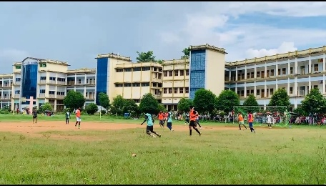
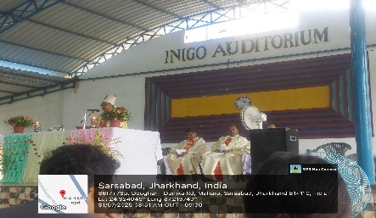

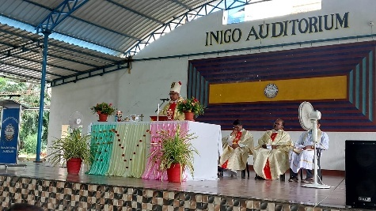
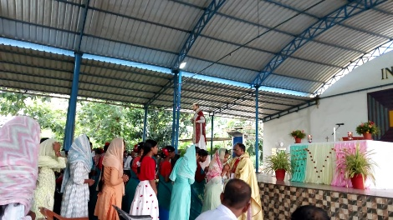
The event concluded on a note of joy and unity, leaving the participants inspired by the life and vision of St. Ignatius of Loyola.

