International Day of the World’s Indigenous People – 2025
St. Xavier’s College, Maharo, Dumka
St. Xavier’s College, Maharo, Dumka, celebrated the International Day of the World’s Indigenous People on 9th August 2025 with great enthusiasm and cultural pride. The programme commenced at 9:00 a.m. with the felicitation of guests and judges by the Principal, followed by the symbolic watering of a plant, representing indigenous values of harmony with nature.
The Vice Principal, Fr. Jesu Raj SJ, delivered the welcome address, setting the tone for the day. Cultural performances such as Santali dance by Binita and group, and Karma dance by Amisha and team, showcased the vibrancy of tribal traditions. The event featured insightful talks by distinguished speakers: Dr. Reena Nilima Lakra on Land Alienation Problems of Tribal People, Fr. Dr. Damian Tudu SJ on Conservation of Tribal Culture: Balance between Tradition and Modernity, and Asst. Prof. Anil Pandit on the Santal Administrative System. Short presentations by Ankita Tudu on Santhal Surnames and Subita Dehri on the History of Paharias further enriched the programme.
A speech competition highlighted students’ perspectives on indigenous issues, judged by Mr. Henry (Dept. of English), Mr. Mahendra Hembrom, and Ms. Nivedita (Dept. of Physics). The segment Lagrae Enec brought a musical close to the cultural performances.
Earlier in the week, related competitions were organised to engage students: a pot painting competition showcasing indigenous art motifs and a quiz competition on Santhal migration, mythology, and history. These events encouraged creativity and knowledge-building while deepening awareness of indigenous heritage.
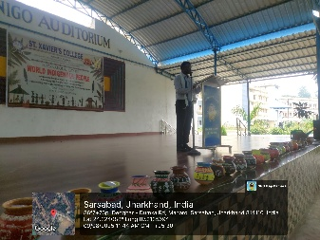
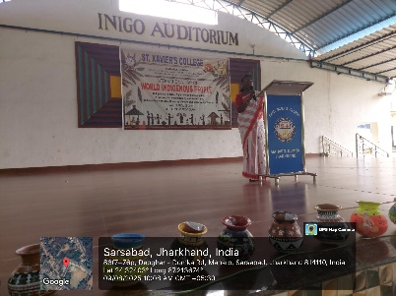
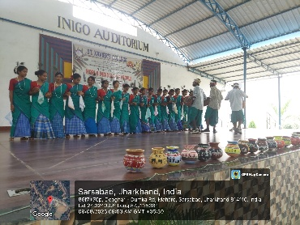
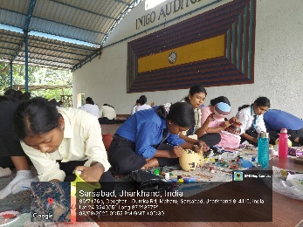
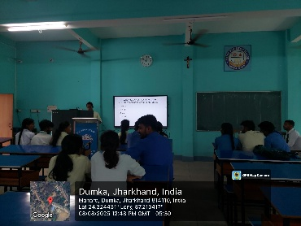
Prizes were awarded to competition winners, and Asst. Prof. Amit Kr. Hansdak delivered the vote of thanks, expressing gratitude to all contributors. The celebration reinforced the importance of preserving indigenous heritage while adapting to modern challenges, leaving participants and audience alike inspired to uphold the dignity and rights of indigenous communities.
